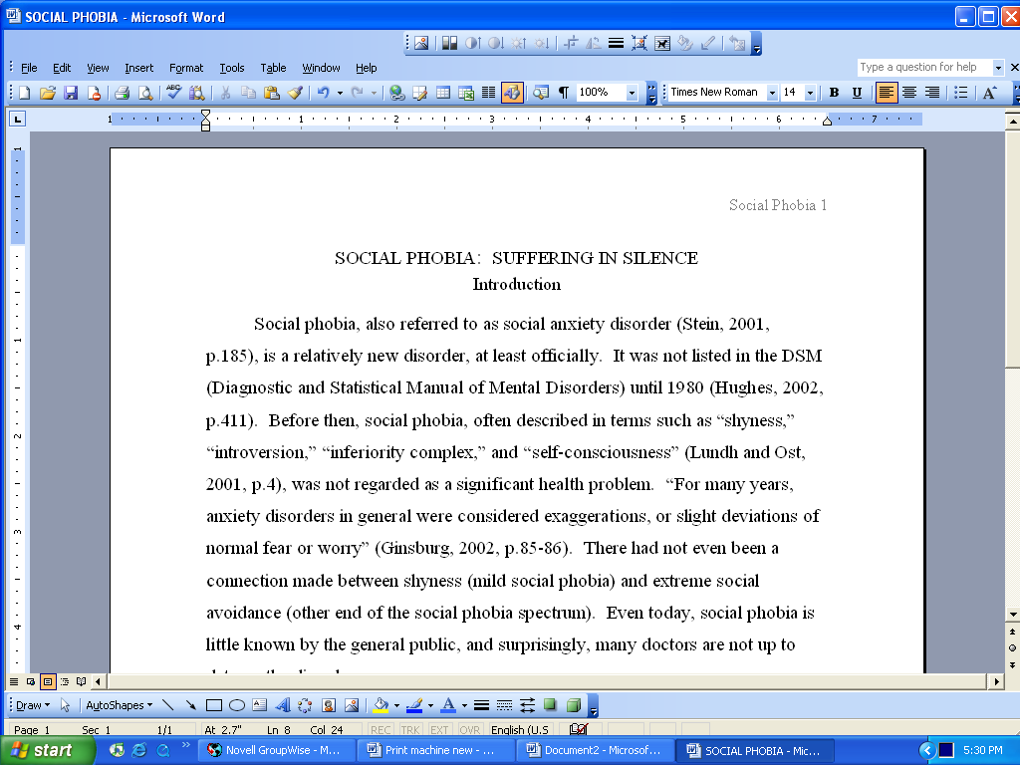
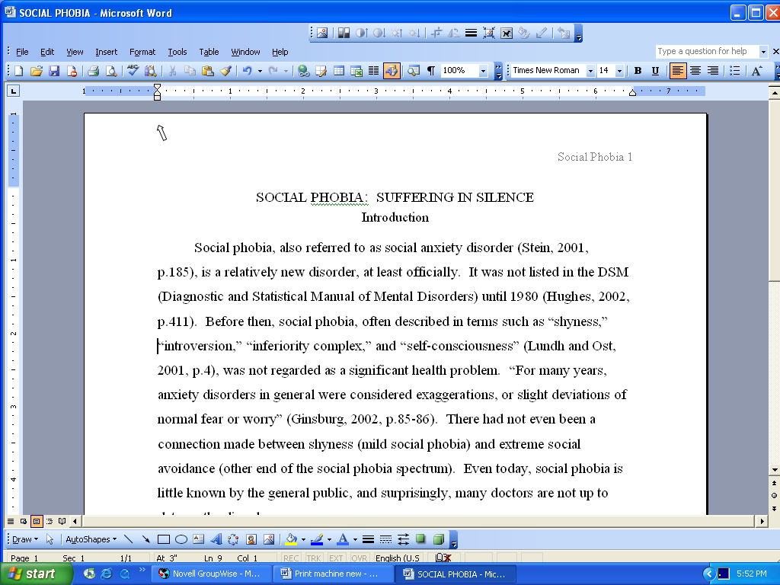
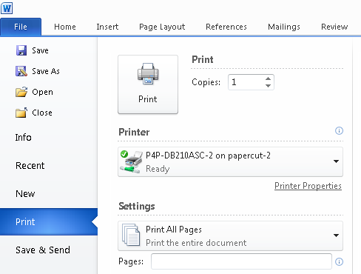
Using the ASC’s PaperCut PRINT SYSTEM
Step 1:
- Click on FILE, then PRINT.

- Click on the square that says PRINT.
- Wait for the Login screen to appear (this may
take a few moments.)
- Type your Username (Student I.D.)
- Type your Password (your Falcon Online password.)
- Click OK and wait for a confirmation screen to appear.
- After checking that all the information is correct, click print.
- You will receive a message that your printing is being held in “queue”. Click OK.

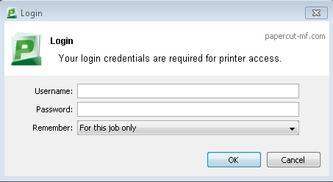

Step 2:
Print as you normally
- Click on the PaperCut icon on the desktop.
Log on to your PaperCut account using your student I.D. and your Password (your Falcon Online password).
- Click on Jobs Pending Release
from the menu on the left.
- A release screen will appear showing all of your print jobs.
- Click Print by the jobs you want to print or click on Release All to print all jobs in the queue.
- Prints will automatically come out of the designated printer for the computer you are using (if nothing comes out right away, click on the Refresh Now to try again.)

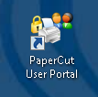

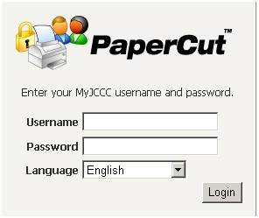

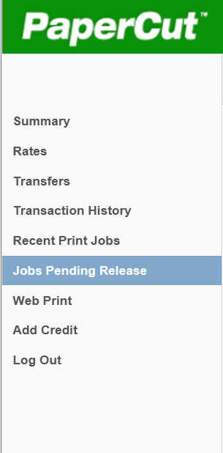
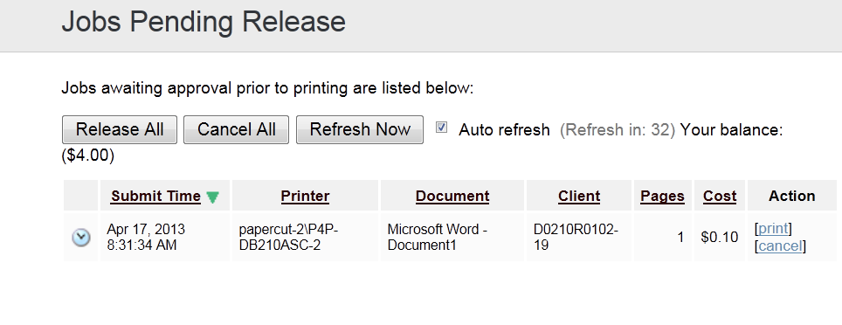

How to Pay Using the PaperCut Print System
Paying for Prints Online:
- Click on the PaperCut icon located on the desktop of any DSC computer (you cannot print at all unless you have done this at least once to activate your account).
- Type in your Username (student I.D.).
- Type in your Password (your Falcon Online password) Your Account Summary will appear.
- Click on Add Credit (have your credit card information ready).
- From the drop-down list in the Amount to add field, select the amount you will add to your account and click the Add Value button.
- You will be taken to the ONLINESTORE where you will confirm the amount and click Continue.
- Fill in your credit card information and click BUY to complete the transaction.
- Confirm the appropriate amount was added to your balance.

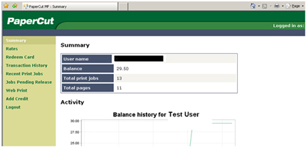

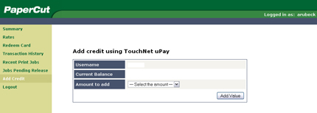

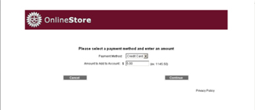

Print as you normally

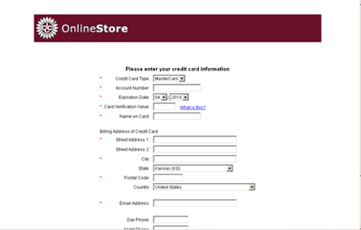

Paying for Prints with Cash:

- Go to the Student Accounts office in Bld. 100 Rm. 102 (or the designated location
on your campus) and ask one of the desk clerks about adding to your
PaperCut printing account.
- A minimum of $2 is required to start your account.
- 10¢ for printing and copying, and free to scan.

